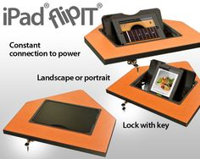

- This is one way modern technology can be put into the design but the desk will be bigger to fit more than just the ipad or laptop and will also include an outlet for the tech to charge at all times as sometime kids forget to plug them in.
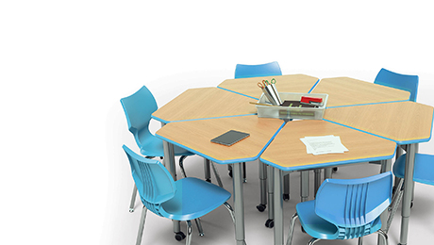
- This design has easily adjustable tables and the material is easy to clean also. These desks also have a colorful design that would look nice in a classroom environment and can also make groups or come apart easily.

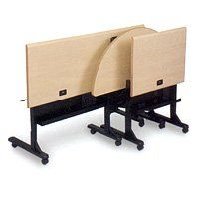
Use of the way these tables fold would allow for the easy storage of the desks during breaks in order for janitors clean rooms better without going through or making teachers go through the pain of moving desk out of the way that are fairly big and hard to move.

